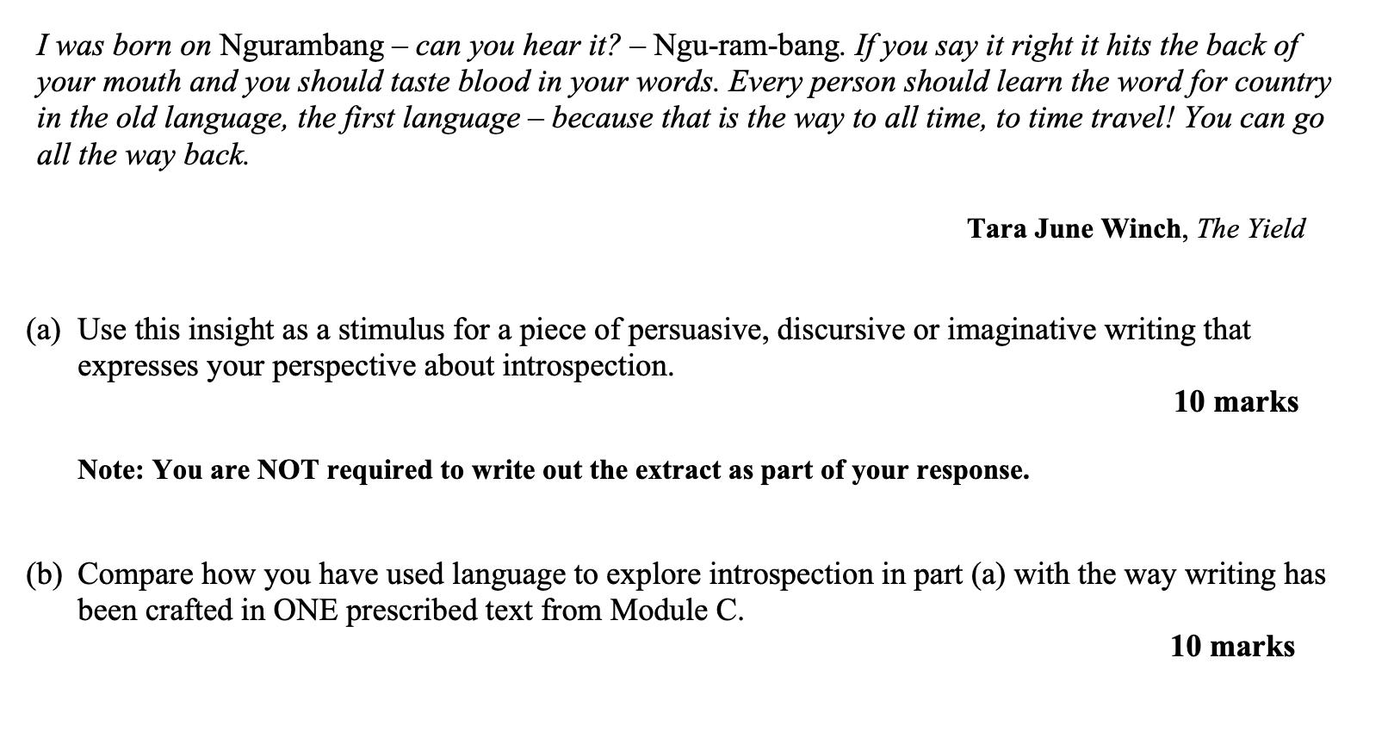
Introspection, connection to country.
What have I missed?
I stutter, I nod, I try to understand. What have I missed?
The words at the dinner table fell like breadcrumbs, half-formed, half-english filled with Afrikaans inflections. My grandmother sits opposite me, wiry hands folded. I smile too much, too wide, ‘ja ja ja’, but everything seems to slip past, the vowels foreign their tongue too fast. My stomach grumbles from my 10 thousand kilometer flight, but no one seems to hear it over the laughter. They talk about people I’ve never met, places I’ve never been, about my country I do not understand. The table stretches between us like an ocean of separation. What have I missed?
“Yoh still remember Ouma’s koeksisters ne?” my uncle chuckles, unintelligible.
This was meant to help, I wanted to reconnect with my country, write about myself, who I am for university. My mother has returned to Durban South Africa for the first time since her leaving, her absence not just distance but resistance. She’d buried this history under layers of assimilation, postponing her return until it could no longer be avoided. And now we’re here, both of us out of place in our own country.
Occasionally, she would make a soulless curry from a jar back in our suburban apartment in Marrickville, but I never had any real connection. I never spoke the language, I don’t even know the word for country. I grew up with flat vowels and vegemite, I never knew milktart or fried dough. No melktert or vetkoek.
The table watches the kitchen, like vultures eager.
My grandmother places the bunny chow in front of me, “Eet” thick spiced curry flowing from a hollowed out loaf of white bread. It’s comforting, the scent is warm, familiar, peppery almost like the version mum made at home, only this one tastes real, it’s rougher, richer, non-westernised.
My Aunt Leizel begins a story, her 16th birthday. She’d dressed her best, only to be told to wait outside with her mother, while my mother and grandfather were allowed inside. My mother was the fair skinned daughter of a now estranged European father and a Black mother chosen by the claw machine of racial privilege at birth. “You got to sit inside” Leizel continued, a smile faltering on her face, almost loving. A complicated wound.
Then someone laughs, and just like that the moment collapses. Voices erupt, clashing, fighting to fill the silence that lingers like smoke. I force out a chuckle, though my stomach churns. I do not understand the punchline, a joke no one dares explain. I don’t feel a connection to this land, the blood line connection isn’t thicker than water. Or maybe it's the blood of the covenant I was raised in is thicker than the water of the womb. What am I missing?
I glance at my mother, but she is still a stranger just as I am. Her shoulders tense at the sound of her cultural name ‘Tsaltsa’ rolling off my grandmother's tongue, but she does not remind her that she’s been Michele for longer than she’s ever been Tsalta, that she’s given up her connection to her country. Did she give up this connection because of this history or was it to give me the chance at a better life?
The hollow out bread has collapsed under the weight of the curry. Crumbs and spice streaks the table cloth. The meal is gone, but I am still hungry, but not for food, for something lodged in the throat. I want to learn the name of my country in my cultural tongue.
I try, I shape the words in my mouth, forcing my tongue into unfamiliar shapes “Vot hek et gemis”. The words are clumsy, butchered with accent, but I’m trying to reconnect trying to connect back. What have I missed?
At my Sydney home, I’ve been allowed to go further, given more opportunities, but I have also been starved. Here at this table, between the broken memories and disconnection, I sit hungry.
b)
My creative piece What Have I missed? Explores the protagonist's first encounter with his African family, where an anecdote of apartheid struggle sparks introspection into his inherited silence and disconnection between his heritage and identity. Storytelling is central with the setting developed around a shared meal of bunny chow that symbolises cultural displacement, inherited silence and fractured identity. Taking inspiration from Nam Le’s love and honour I adopt his cultural setting and non-linear narrative structure, in order to catalyse the introspection where my protagonist reflects on his fractured identity and realises his desire to reconnect.
Akin to Le, I use non-linear narrative structure to connect the past and present. Just as Nam Le shifts between fragmented recollections and present day interactions “Maybe he didn’t tell it exactly that way”, I sought to mirror this temporal fluidity in my own piece. This is evident in the shifting between apartheid anecdotes and the introspective reflection in the protagonist “My aunt begins a story… the blood of my covenant is thicker than the water of my womb” where I use the recollection of the past as a catalyst that creates the introspection of the protagonist where he comes to terms with the extent of his cultural disconnection. Furthermore, I highlight how stories are not experienced linearly, but instead re-emerge over time “The meal is gone, but the hunger remains” In doing so, I encapsulate the duality of time and allow for the protagonist to go through an introspective moment where he reflects on his silenced identity that he inherits due and his desire to reconnect with his African family.
In crafting my setting, I sought to mirror Nam Le’s immersive evocation of a place, where the environment becomes a tactile extension of memory and identity that allows for the protagonist to undergo an introspective moment where he weighs the impact of silence identity. Just as Le’s protagonist sits of the periphery of a sensory rich Vietnamese cultural gathering “A thicket of Vietnamese voices cursing toasting”, I place my protagonist in a similarly charged environment that he also cannot connect to ‘My uncle chuckles, unintelligible’ that becomes a moment of realisation where the protagonist starts his introspective journey ‘I never spoke the language, I don’t even know the word for my own country’ that uses a bathetic realisation to explore the cultural displacement that he experiences, revealing how setting operates as more than just a backdrop; it becomes the place where memory, identity and trauma intersect.

